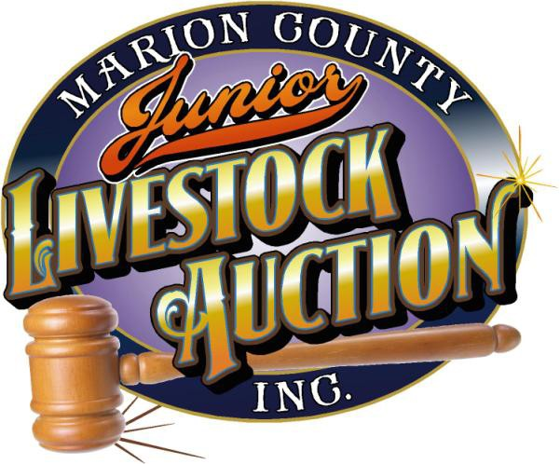

Dear Buyer,

Mark your calendars for the 2017 Marion County Junior Livestock Auction (MCJLA) on July 8, 2017!
We hope you can make it to the auction and make 2017 our best ever. The meal will begin at 3:00 PM and the auction will begin at 5:00 PM.

MCJLA registration at the Fair begins at 2:30 PM. You will be provided a buyer number which will allow two people to enter our dining area between 3:00 PM - 5:00 PM for a delicious meal.

All animals that the Buyer indicates as Live Pickup will need to be picked up starting at 11:59 PM on Saturday evening following the auction. Buyers selecting this option must be personally present with paperwork to pick up the animal purchased. The MCJLA is required by the Marion County Fair Board to load out all animals sold at the auction at this scheduled time.

We will be accepting credit card payments with MasterCard, Visa, Discover and American Express. There will be a flat 2.75% transaction charge for an approved credit card.

If you would like to give a deserving 4-H or FFA kid an Add-On, or make a donation to our Scholarship Fund, forms are available on our website at www.mcjla.com under the donation tab. Your support is needed and greatly appreciated!

Don't forget to save the date on your calendar. Hope to see you there!

MCJLA Directors & Officers

John Kuenzi
Bill Luthi
Becky Bates
Andrea Leao
Mike Clonch
Justin Brill
Jace Anderson Letxy Molin
Josh Augustus
Carol Barham

