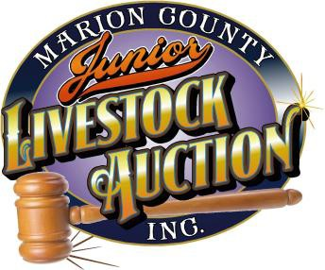2018 4-H and FFA Livestock Exhibitor Scholarship (Marion County Only)

Donor: Marion County Junior Livestock Auction – Auction Donors County Award: A Scholarship open to current 4-H and FFA members Scholarship Value: Up to Four (4) awards not to exceed $1000.00 each
Background: Scholarships will be awarded to high school Seniors who are current 4-H or FFA members who are enrolling in any accredited college, university, community college, or technical school in the Fall following scholarship award.

Purpose:
- To expand interest, support and participation in the Marion County Junior Livestock Auction and 4- H/FFA programs.
- To encourage the development of leadership skills, build character and citizenship responsibilities.
- To encourage the development of skills that will contribute to a more efficient, productive and profitable life.
- To provide for recognition of meritorious work and achievement in 4-H or FFA furthering the college education of 4-H and FFA members.

Eligibility:
- Applicant must be a current high school senior and planning to enroll as a first year freshman at a college, university, community college or technical school in the fall of the graduating year.
- Applicant must be in good standing with the Marion County 4-H Program and/or FFA Chapter.
- Applicant must have participated in a 4-H/FFA livestock auction program two of the past three years.

County Application Requirements:

Your application will be denied if any of the following requirements are not included.
- Complete application form attached.
- Provide two letters of recommendation – from non-family members. One must highlight your FFA or 4-H experience. Letters must have original signature of the person making the recommendation.
- Please provide following information on a separate sheet of paper
  - List your years and all involvement in activities 4-H Club or FFA Chapter.
  - List your involvement in school and community activities.
  - Describe you occupational/career goals and include you course of studies and why you selected it. Include the steps necessary to reach your goals.
  - Add any additional information you would like to share.

Distribution:

Recipients of award must enroll as full-time students in any accredited college, university, community college or technical school of choice. Scholarship funds will be made directly to the school in your name once you provide proof of registration. Your proof of registration form, must include your student number, College name and address must be sent to the MCJLA, P.O. Box 613, Silverton, OR 97381 to receive payment. If proof of registration is not provided prior to July of the following year, the award will be deemed null and void and remain in the scholarship fund for award to other applicants.

Note: Recipients elected as Oregon State FFA officers can postpone receipt of their scholarship for one year.

*Please do not submit original documents and please do not submit a “scrapbook”. Your completed application and required attachments must be postmarked by: 8pm May 3rd, 2018 ( May turn in at weigh in)
Mail directly to:
Marion County Junior Livestock Auction PO Box 613
Silverton, OR 97381

2014 4-H and FFA Livestock Exhibitor Scholarship Application

Please type or write legibly in black ink.

NAME

ADDRESS CITY/ZIP

TELEPHONE ( )

High School Graduating From:

Cumulative High School GPA:

4-H Club or FFA Chapter:

College, University, Community College or Technical School planning to attend in the Fall:

Original Signatures Only:

Applicant Signature Date

Parent/Guardian Signature Date

4-H Leader/FFA Advisor Signature Date

